Artificial Intelligence Lab

Lab Manual 09



Department of Cyber Security

HITEC University Taxila

Introduction to external libraries and

Implementation of PANDAS and Matplotlib and their functions

Objective
- To understand the basics of PANDAS and Matplotlib
- To visualize results in the form of graphs

Software
- Python, Pycharm or VS-Code IDE

Theory

PANDAS
Pandas is a Python library used for working with data sets. It has functions for analyzing, cleaning, exploring, and manipulating data. The name "Pandas" is a reference to both "Panel Data" and "Python Data Analysis" and was created by Wes McKinney in 2008.

Key Data Structures:
- Series: 1-D labeled array capable of holding any data type.
- DataFrame: 2-D labeled data structure with columns that can hold different data types.

Installation:
pip install pandas

Importing Library
import pandas as pd

Creating a Series:
s = pd.Series([10, 20, 30], index=['a', 'b', 'c'])
#A Series is like a column in a table, but it can also be used as a standalone object.

Creating a DataFrame:
data = {
'Name': ['Ali', 'Awais', 'Qasim'],
'Age': [25, 30, 35],
'City': ['Lahore', 'Islamabad', 'Taxila']
}
df = pd.DataFrame(data)

output
Name Age City
0 Ali 25 Lahore
1 Awais 30 Islamabad
2 Qasim 35 Taxila

Reading Data From CSV/Excel:
df = pd.read_csv('file.csv')
df = pd.read_excel('file.xlsx')

Viewing Data
df.to_string() | Print entire dataset
df.head() | Print First 5 rows
df.tail(3) | Print Last 3 rows
df.info() | Print Info summary
df.describe() | Print Stats summary
df.shape | Print (rows, columns)
df.columns | Print Column names
df.index | Print Row indices

Select specific columns:
df[['Age', 'Blood Pressure', 'Heart Disease Status']].head()

Filter Data
# Patients older than 60 with Heart Disease
df[(df['Age'] > 60) & (df['Heart Disease Status'] == 'Yes')]

Sort Data
df.sort_values(by='BMI', ascending=False).head()

Rename column
df.rename(columns={'Cholesterol Level': 'Cholesterol'}, inplace=True)

Creating a new column
df['new']='ok'

Count values
df["Gender"].value_counts()

drop column
df.drop(columns=['CRP Level'], inplace=True)

Null values
df.isnull().sum()

drop null values
df.dropna(subset=['Gender'], inplace=True)

Matplotlib Library
Matplotlib is a low-level graph plotting library in Python that serves as a visualization utility. John D. Hunter created Matplotlib. It is open source, and we can use it freely. Matplotlib is mostly written in Python, but a few segments are written in C, Objective-C, and Javascript for Platform compatibility.

Installation:
pip install matplotlib

Importing Library

Pyplot
Most of the Matplotlib utilities lie under the pyplot submodule and are usually imported under the plt alias:
import matplotlib.pyplot as plt

Histogram
Think of histograms as a more informative way to view the distribution or values in a dataset. It is ideal for visualizing the spread and variation of the data, helping you identify outliers or unusual data points that fall far outside the normal range of the data.
plt.figure(figsize=(8, 5))
plt.hist(df['age'], bins=10, color='skyblue', edgecolor='black')
plt.title('Age Distribution')
plt.xlabel('Age')
plt.ylabel('Frequency')
plt.grid(True)
plt.show()

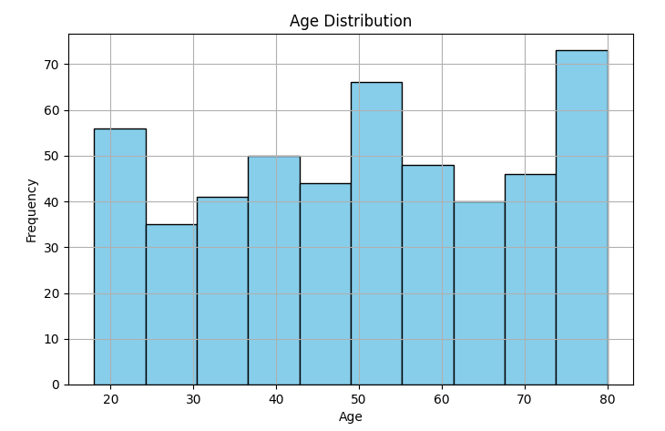

Box Plot:
The box plot distribution will explain how tightly the data is grouped, how the data is skewed, and also about the symmetry of data.
# Blood pressure by gender.
plt.figure(figsize=(8, 6)) # Define figure size
df.boxplot(column='Blood Pressure', by='Gender', grid=False) # Grouped box plot
plt.title('Blood Pressure by Gender')
plt.suptitle('') # Remove automatic title
plt.ylabel('Blood Pressure')
plt.show()
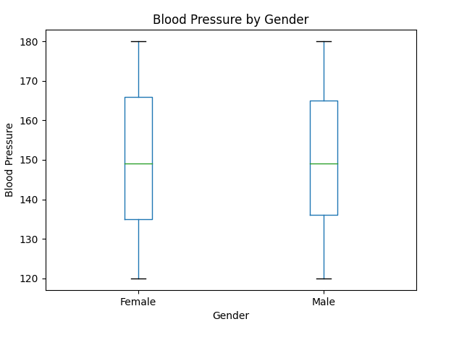

Bar Plot
Bar charts are excellent for comparing the values of different categories or groups. Apart from that, these types of charts are also helpful in showing the distribution of data across different categories.

Heart disease status count:
df['Heart Disease Status'].value_counts().plot(kind='bar', color='coral') # Bar chart
plt.title('Heart Disease Status Count')
plt.ylabel('Number of Patients')
plt.xticks(rotation=0) # Keep x-labels horizontal
plt.show()
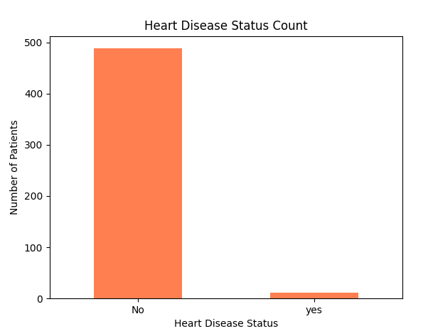

Pie Chart
It is a circular, statistical graphic that divides data into slices. Each slice represents a percentage or proportion of the whole. This classic chart type is effective when you want to illustrate the proportion of each category in the dataset.

Proportion of genders:
df['Gender'].value_counts().plot(kind='pie', autopct='%1.1f%%', startangle=90, colors=['lightgreen', 'lightblue']) # Pie chart
plt.title('Gender Distribution')
plt.ylabel('') # Hide y-label
plt.show()
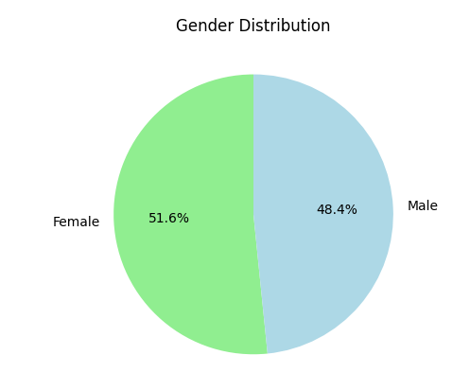

Scatter Plot
Scatter plots are ideal for exploring relationships and patterns between two continuous variables. They can help you identify trends, correlations, or potential clusters in the data.
plt.scatter(df['Age'], df['Blood Pressure'], alpha=0.6, c='purple')
plt.title('Blood Pressure vs Age')
plt.xlabel('Age')
plt.ylabel('Blood Pressure')
plt.grid(True)
plt.show()
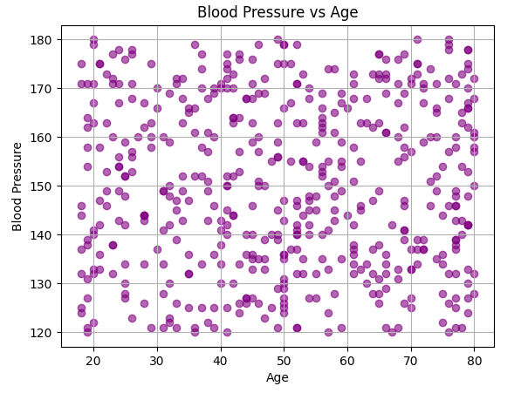

Lab Tasks:
- What is the mean age of individuals in the heart_disease dataset?
- How many people have heart disease, and how many do not?
- What is the maximum and minimum cholesterol level?
- How many individuals have a BMI over 30?
- List the number of individuals who have high blood pressure and also have heart disease.
- Create a histogram of BMI distribution. What is the most common BMI range?
- Create a bar chart comparing the number of heart disease cases across different exercise habits.
- Which group has the lowest heart disease risk?
- Create a pie chart showing the proportion of smokers vs non-smokers.
- What percentage of the dataset are smokers?
- Create a scatter plot of BMI vs Triglyceride Level.
- Is there any visible trend or clustering?
- Create a box plot for the Sleep Hours data.
- What is the median number of sleep hours?
- Are there any outliers?

Conclusion

